Abu Dhabi Clinical Costing Road Map
Implementation of Clinical Costing Road Map for the Emirates of Abu Dhabi is a continuation of the Clinical Costing and Value Based Funding Framework Project wherein a comprehensive Clinical Costing and Funding Framework for the Emirate of Abu Dhabi was developed with healthcare providers engagement and support.
The purpose of Clinical Costing Road Map Implementation is to establish Abu Dhabi Clinical Cost Data Collection process for collecting accurate, consistent, and meaningful cost data from all healthcare care providers.
Abu Dhabi Clinical Costing Road map has three distinct facets as explained below:
Abu Dhabi Clinical Costing Standard: The standard provides the costing principles and processes to be followed by providers for the calculation and submission of cost data to the Department. The DOH published Abu Dhabi Clinical Costing Standard in November 2024.
Abu Dhabi Clinical Costing Guideline: The guidelines provide a detailed explanation for standard to be followed by providers for calculating and submitting cost data to the Department. The DOH published Abu Dhabi Clinical Costing Guidelines in November 2024.
Abu Dhabi Clinical Cost Data Collection Technical Document: The document provides the technical details relating to data specifications, validations and platform to be used for the submission of cost data.

What do you need to do?
- Register Clinical Costing Contact: It is mandatory to register your facility designated clinical costing contact person using the "Register of Key Contacts" form.
https://forms.office.com/r/wbswwxWh6F
- Submit Questions: All questions must be submitted via the "Abu Dhabi Clinical Costing - Questionnaire" form. We appreciate your adherence to this structured communication channel.
- Meetings Need: If you encounter any issues or blockers that require a meeting, please mention them while filling out the questionnaire. The DOH clinical costing team will assist and arrange a meeting with your team.
- Clinical Costing Data Submission Readiness Survey: It is mandatory for all the providers to complete the Clinical Costing Data Submission Readiness Assessment.
https://forms.office.com/r/UQcMyHg5Ea
- Shared Drive Access: We have shared training materials and session recordings with all the primary contacts through DOH shared drive access.

High Level Timelines
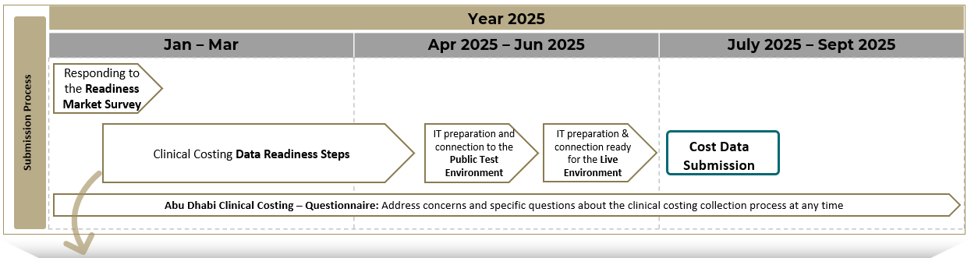
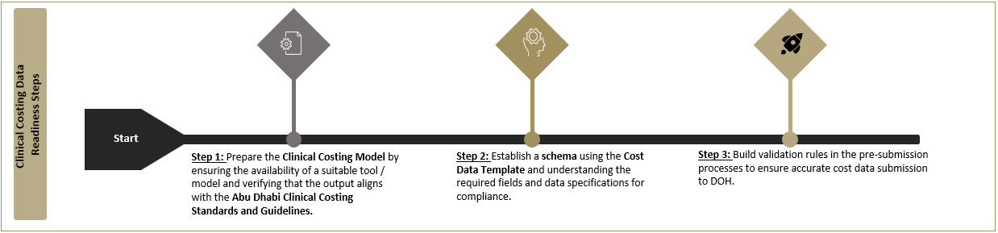

Abu Dhabi Clinical Cost Data Collection Submission Timelines:

Who needs to comply with Abu Dhabi Clinical Costing Standard?

Scope of Clinical Costing:
- Applicable Facilities: All healthcare facilities providing direct patient care (regardless of the facility size).
  - Exceptions:
    - Stand-alone Outpatient Pharmacies
    - Stand-alone Diagnostic Centers
Explanation of Exceptions:
- Stand-alone Outpatient Pharmacies:
  - Operate independently and are not included in a direct patient care facility's operational cost.
  - Therefore, they do not need to provide clinical costing data.
- Stand-alone Diagnostic Centers:
  - Categorized under Third-Party Expenses - Purchased services
  - The costs of services provided by these facilities are recorded as purchased services in the general ledger of the healthcare facilities that utilize their services.
  - For example, if healthcare facility A uses services from a stand-alone diagnostic center, the cost of those services is attributed to the patient receiving care at healthcare facility A and should be recorded in the general ledger of healthcare facility A.
  - Therefore, stand-alone diagnostic centers are not required to submit costing data, as they don’t treat patients directly and their costs are already included in the facility using their services.

The Background of Abu Dhabi Clinical Costing Road Map
DOH initiated Clinical Costing and Value Based Funding Framework Project, a 15-month period project structured across three distinct streams, tailored to meet the project’s objectives with the second and third streams running in parallel. This was successfully completed in August 2024.
With over 50 engagement sessions held so far, continuous conversations for ideation, input, and alignment with internal and external stakeholders has been a cornerstone of the project.
Internal and external engagement sessions held
- 9 Steering Committee Meetings
- 8 Market Advisory Committee Meetings
- 26 Costing Technical Group Meetings
- 25 SME Working Sessions

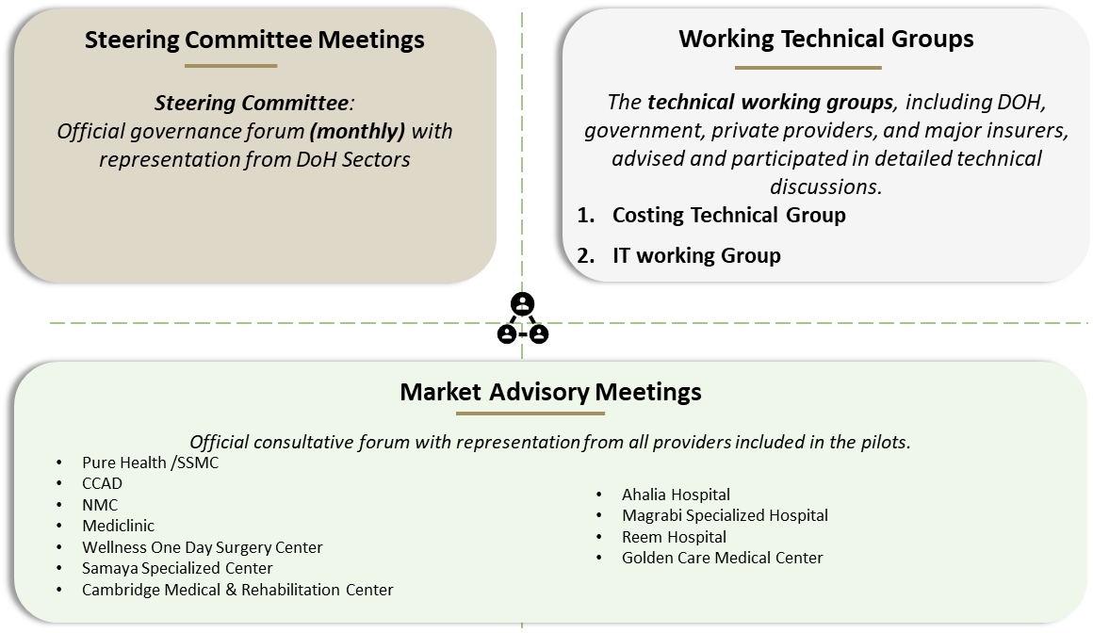

One of the critical components of Clinical Costing and Value Based Funding Framework project is implementation of Abu Dhabi clinical costing roadmap implementation enabling the DOH to collect annual patient level cost data from providers.

