

|  |  |  |
| --- | --- | --- |
| **Addendum 31 to DOH Claims & Adjudication Rules** | **Version**  **V2012** | |
| **Including the Mandatory Tariff Pricelist Application Rules.** | |  |

1. **Purpose of this Document.**

This Addendum is issued to update the reimbursement packages for the Comprehensive Screening Program and retire all previous addendums.

1. **Effective Date:**

30 June 2023.

1. **Service Codes:**

|  |  |  |  |
| --- | --- | --- | --- |
| Code | Short Code Description | Long Code Description | Price |
| 52-21 | Comprehensive Screening Major Package for male & female (age 18-39 years) | Comprehensive Screening Major Package for male & female (age 18-39 years) for consultation & Labs including the following services every 3 years: • 99201 • 96127 • 36415 • 82947 • 83036 • 80061 • 82565 | 220 |
| 52-22 | Comprehensive Screening Major Package for male & female (age 40-64 years) | Comprehensive Screening Major Package for male & female (age 40-64 years) for consultation & Labs including the following services every 3 years • 99201 • 96127 • 36415 • 82947 • 83036 • 80061 • 82565 | 220 |
| 52-23 | Comprehensive Screening Major Package for male & female (age 65-75 years) | Comprehensive Screening Major Package for male & female (age 65-75 years) for consultation & Labs including the following services every 3 years: • 99201 • 96127 • 36415 • 82947 • 83036 • 80061 • 82565 | 220 |
| 52-24 | Comprehensive Screening Minor Package for male & female (age 65-75 years) | Comprehensive Screening Minor Package for male & female (age 65-75 years) for vision & hearing including the following services annually: • 92551 • 99173 | 52 |
| 52-25 | Comprehensive Screening Oral Health Package for male & female (age 18-75 years) | Comprehensive Screening Oral Health Package for male & female (age 18-75 years) for oral examination & oral hygiene including the following services annually: • 01103 • 13211 | 105 |
| 52-26 | Colon Cancer Screening male & female (age 40-75 years) | Colon Cancer Screening Package for male and female (age 40-75 Years) including the following services every 10 years: • 99201 • G0105 | 868 |
| 52-27 | Cervical Cancer Screening for female (age 25-29 years) | Cervical Cancer Screening Package for female (25-29 Years) including the following services every 3 years:  • 99201 • 88142 | 130 |
| 52-28 | Cervical Cancer Screening for female (age 30-65 years)  for eligible groups based on PCSP standard | Cervical Cancer Screening Package for female (30-65 Years) including the following services every 5 years:  • 99201 • 88142 • 87623 or 87624 or 87625 | 246 |
| 52-29 | Lung Cancer Screening for (High Risk) male & female (age 55-75 years) | Lung Cancer Screening Package for male & female (age 55-75 Years) for (high risk only, heavy smokers) including the following services annually:  • 99201 • 71250 | 490 |
| 52-30 | Standalone Screening Mammography for female for eligible groups based on PCSP standard | Standalone Screening Mammography for female every 2 years (77067) for eligible groups based on PCSP standard | 293 |
| 52-31 | Standalone Screening Fecal immunochemical test (FIT) for eligible groups based on PCSP standard | Standalone Screening Fecal immunochemical test (FIT) annually (82274) for eligible groups based on PCSP standard | 57 |
| 52-32 | Standalone Screening Abdominal Aortic Aneurysm for eligible groups based on PCSP standard | Standalone Screening Abdominal Aortic Aneurysm once in a lifetime (76706) for eligible groups based on PCSP standard | 202 |
| 52-33 | Standalone Screening DEXA scan for eligible groups based on PCSP standard | Standalone Screening DEXA scan every 3 years (77080) for eligible groups based on PCSP standard | 133 |

1. **Claims and Adjudication Rules**

* The screening program codes 52-21 to 52-33 must be only reported with Encounter Type 7 = Nationals Screening. Refer to Table 1 for the list of appropriate screening codes for each age group and gender.
* An observation must be reported in the eClaim with the use of Codes 52-21 to 52-33 as defined in Routine Reporting Requirements published on <https://www.doh.gov.ae/en/Shafafiya/reporting>
* For the services that are included in the service codes, providers are required to report the codes as activity line at claims level but keep charges at a value of zero as a prerequisite for reimbursement.
* All activities within each screening package are required in order to bill for a comprehensive screening package service code, missing activities due to medical reasons would be accepted for payment purposes based on proper documentation.
* Reimbursement for codes 52-21 to 52-33 shall not be allowed with CPTs 99201-99215, 99401– 99412, 96160 and 99381-99387; if billed by the same facility, for the same patient, same principal diagnosis (Comprehensive Screening) on the same date of service.
* “E&M Follow up within one week” rule shall not be applicable to service codes 52-21 to 52-33. Hence, reimbursement shall be allowed for subsequent Evaluation and Management office visit, if deemed medically necessary.
* Coding and reimbursement of subsequent services (as below) shall be based on the medical necessity determined by the initial screening outcomes or services prescribed by DOH comprehensive screening program standard. Whereby;
* Preventive medicine counseling CPT codes (99401 – 99412, 96160) shall be allowed for patients with established medium to high risk factors and/or further investigation or diagnostic services on any abnormal finding detected from the screening services.
* In the absence of established risk factor or for subsequent encounter after counseling was commenced, and where abnormal finding were detected; such encounters shall be billed and reimbursed using the E&M codes as a medical condition and not a preventive service.
* In case of duplication of tests between IFHAS and other screening programs under Thiqa within a period of 90 days, the cost of that test will be subject to recovery.
* Eligibility of the above codes will be as per the DOH Comprehensive Screening Program standard.

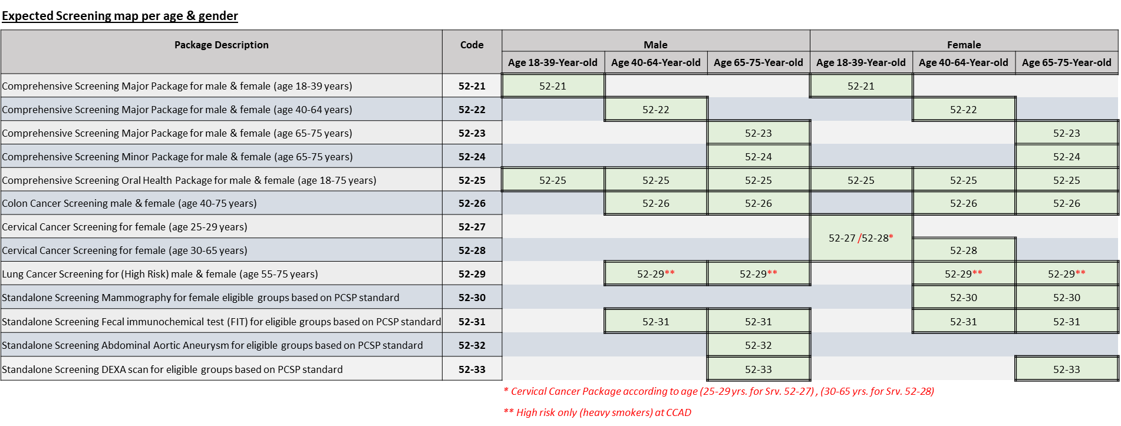Table 1: Expected Screening map per gender & age group